C:\STOCKLAYOUTS\CURRENT PROJECTS\FN99807-PL\FN99807-IMG03.emf

**RECHARGE your leadership**

**at the**

**BRL Reunion**

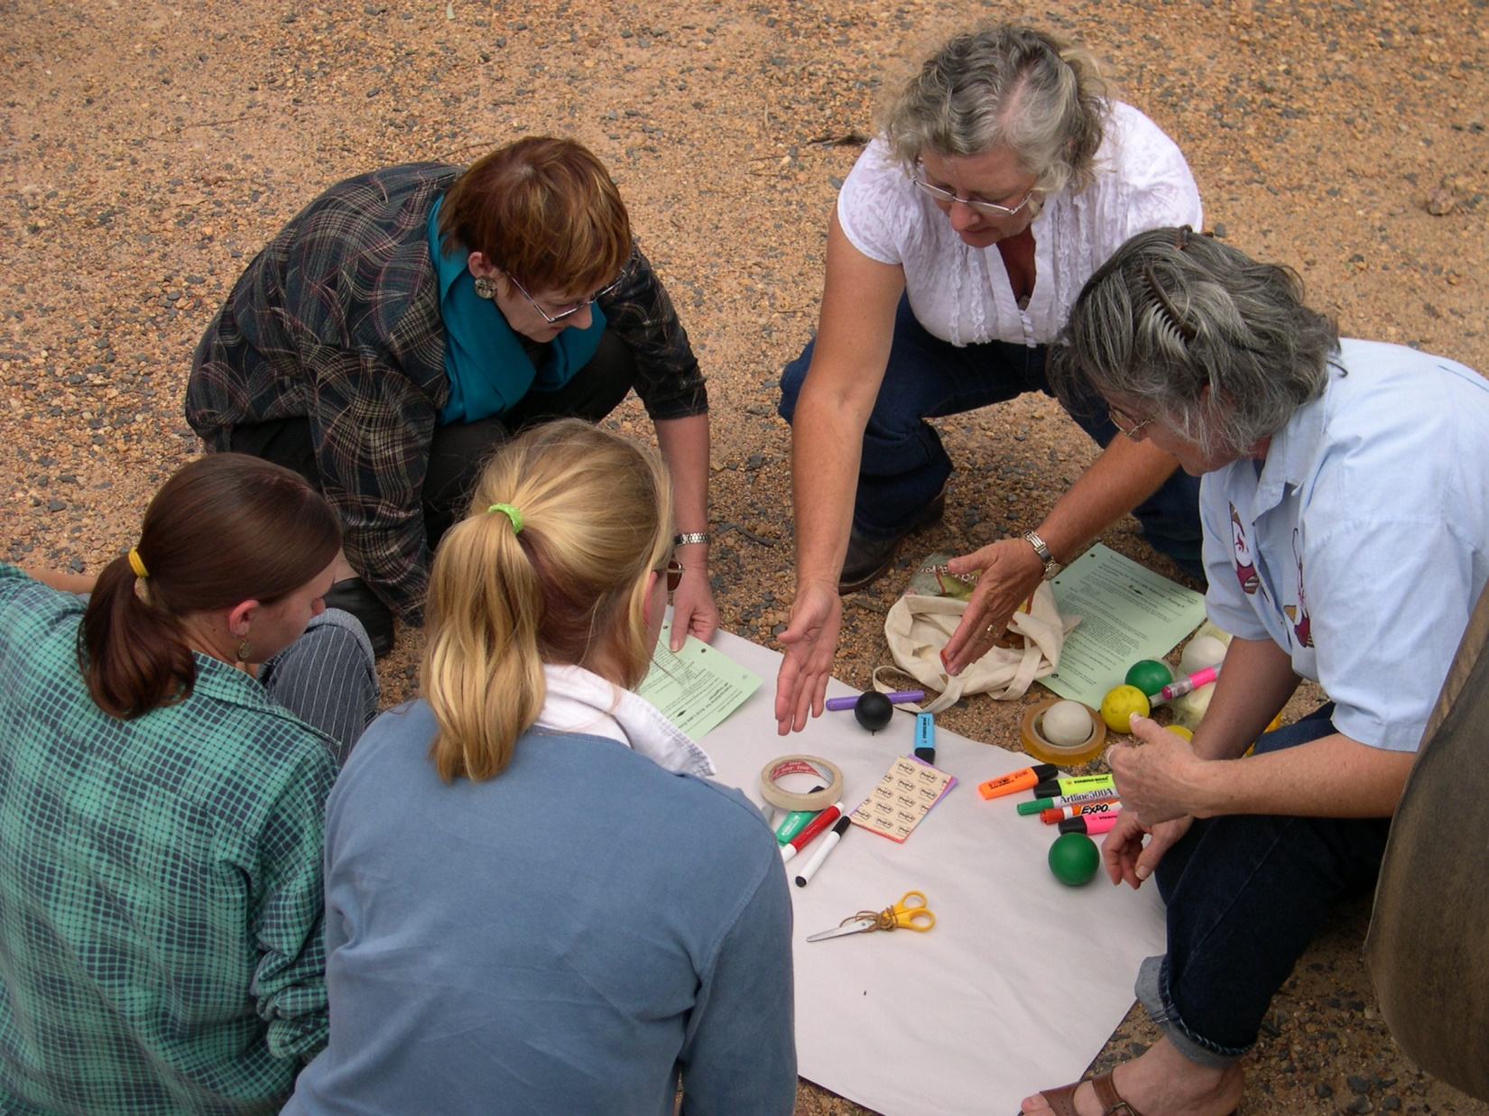

* **Reflect on and refresh your BRL experience**
* **Learn latest thinking and research on leadership**
* **Connect with old friends, make new friends**
* **Grow our BRL network**
* **Get ready for the future**

**24 - 26 October 2014**

Bunya Mountains Conference Centre

Sponsored by **Vision 21**

*The association of past participants of Building Rural Leaders programs*

* **Register** online Vis21.weebly.com
* **Tell** your BRL friends

## **Presenters**

## **Quentin Jones - Designer & original presenter BRL.**

## Over the past 20 years, Quentin Jones has pioneered the concept of leadership and culture and its links to business performance. His contribution as thought leader, consultant, educator, business and network builder has set Australia as a leader in this field.

## Quentin is currently Managing Director at CLS360 <http://cls360.com/>

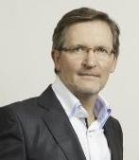

## **Pamela McAllister – Past presenter of BRL.**

## As a past presenter of the Building Rural Leaders program Pam is passionate about building the courage, confidence and skills of people in Regional Queensland to lead themselves and others. She specialises in leadership development, improvement and innovation.

## [mcallisterleadership.com.au](http://www.mcallisterleadership.com.au/)

## **Draft Program**

|  |  |
| --- | --- |
| **Friday**  24 October | Social evening program |
| **Saturday**  25 | A brief journey through BRL  What’s new in leadership – Quentin Jones  Reflecting on our own leadership  Practical exercises in leadership  Drinks and nibbles on the deck  Reunion Dinner - Guest speaker:  Quentin Jones – Designer and original presenter of BRL |
| **Sunday**  26 | Action Learning  More new leadership thinking and practical exercises  Where to from here for Vision 21? |

## The program will use interactive processes to explore effective and ineffective leadership behaviours using Leary’s interpersonal circumplex. With twenty years application of this model in corporations and government Quentin Jones has a depth of understanding to challenge our thinking and take the next step in our leadership development. Read more about the model at <http://cls360.com/>.

## **Accommodation, Food and Event Dinner**

## The BRL Recharge and Reunion event will be held at the Bunya Mountains, a venue familiar to many past participants of Building Rural Leaders. <http://bunyamountains.com.au/>

Registration is now available online at [vis21.weebly.com](C:\\Users\\Pammy\\AppData\\Local\\Microsoft\\Windows\\Temporary Internet Files\\Content.Outlook\\63WXJXUJ\\vis21.weebly.com).

## Packages available include accommodation, catering and event dinner.

## *Vision 21* is supporting the event in order to make the reunion accessible to everyone. In addition, a limited number of sponsored places are available for anyone experiencing financial hardship. Please phone Pamela at 0400 507 390 or Deb at 0415135457 if you wish to apply for this assistance.

## **Sponsor**

## 

Vision 21 is the association of past participants of Building Rural Leaders programs. Its members are passionate about growing leadership, their own, and for people in regional Queensland.

The Vision 21 community is guided by principles including that:

* Leadership development begins with improving our ability to lead ourselves
* Leadership requires continual learning and a willingness to work through change in a proactive way, whether that change is chosen or unchosen
* Leadership is about action, not position. It is not about power over others, but power *with* others, working in partnership to achieve shared goals

If you would like to **become a member** of Vision 21 email us or visit our website for a Registration Form.

## **Next Steps**

* **Register** online Vis21.weebly.com
* **Tell** your BRL friends

**Phone** Deb 0415135457 or Pam 0400 507 390

**Email** [vision21assoc@gmail.com](mailto:vision21assoc@gmail.com)

**[https://s3.amazonaws.com/stocktonthunder/siteimages/facebook_icon.png](https://www.facebook.com/groups/vis21/)Web** <http://vis21.weebly.com/>

**Join** the conversation on Facebook: <https://www.facebook.com/groups/vis21/>